Examples of List Rental Scams- Not Affiliated with NFMT, Trade Press or ROC Exhibitions
NFMT has a registered trademark and they are not legally allowed to use the NFMT name.
If you receive an Email like this, we suggest you block their email address.

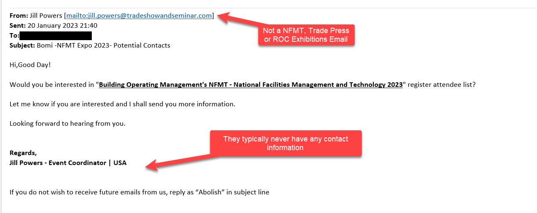

See page additional pages for more examples
