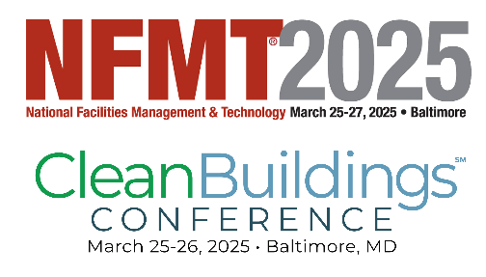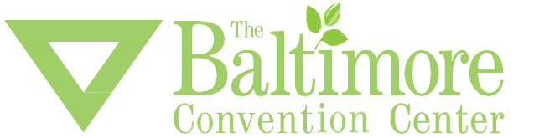

**DIVERSION BY DONATION PROGRAM**

**NFMT** and the Baltimore Convention Center care about the environment and the local Baltimore community. Please help us towards increasing our waste diversion by donating specific leftover items to local organizations.

The BCC works with several local non-profit organizations that could benefit by receiving the items listed below. BCC staff will collect this material and distribute it to non-profits.

**The following may be donated:**

* **Promotional items like pens, pencils, pads of paper, clothing, lanyards, tote bags**
* **Exhibit booth furnishings, such as tables, chairs, and display cases, light fixtures etc.**

**Have something that you’d like to donate?**

**Send an e-mail with an item description and photo (if possible), along with your booth number, to** [**donation@bccenter.org**](mailto:donation@bccenter.org)**.**

**What you have isn’t listed? Send us an e-mail and we will try to match your items with a local organization.**

**Some organizations we work with:**

|  |  |  |  |
| --- | --- | --- | --- |
| **[Logo](https://www.secondchanceinc.org/)** |  | Home » Baltimore Tree Trust | Baltimore Community ToolBank | Baltimore ToolBank |

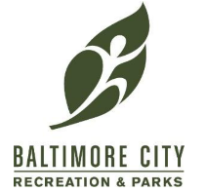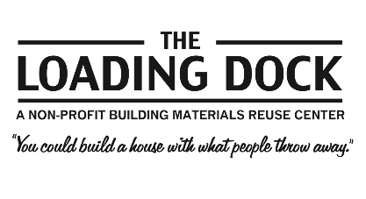



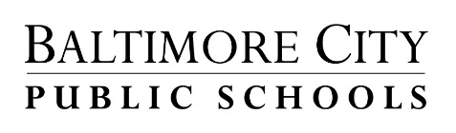

Are you donating items to another organization? Please send photos or a list of items to [donate@bccenter.org](mailto:donate@bccenter.org) so that we may track it in our diversion numbers!

